LAB REPORT实验报告
Lab Title | Function overloading |  |  |  | Lab No. | 12
Stud. Name | Jiang Yunxiang | Major | CST |  | Class
Student ID | 2022102330 |  | Date | 5/12
Lab description/objectives:
Using function overloading, write a function area( ) to calculate the area of a circle, a rectangular, and a trapezoid with one, two and three arguments. Write another function max( ) to find the larger or longer one from two ints or two doubles or two strings.
Source code:
（Paste the source code here）
#include<iostream>
using namespace std;
#define pai acos(-1)
void area(float a)
{
cout << "The area of the circle is:" << pai * a * a << endl;
}

void area(float a, float b)
{
cout << "The area of the rectangular is:" << a*b << endl;
}

void area(float top, float bottom, float h)
{
cout << "The area of the trapezoid is:" << (top+bottom)*h /2 << endl;
}

void max(int a, int b)
{
if (a > b) cout << "The larger one is:" << a << endl;
else cout << "The larger one is:" << b << endl;
}

void max(double a, double b)
{
if (a > b) cout << "The larger one is:" << a << endl;
else cout << "The larger one is:" << b << endl;
}

void max(string a, string b)
{
if (a.length() > b.length()) cout << "The longer one is:" << a << endl;
else cout << "The longer one is:" << b << endl;
}

int main()
{
area(2);
area(1,2);
area(2,2,2);
max(1, 100);
max(12.11,13.2323);
max("ABC","1234");
system("pause");
return 0;
}
Program outputs:
（Paste the screenshot of program output here）
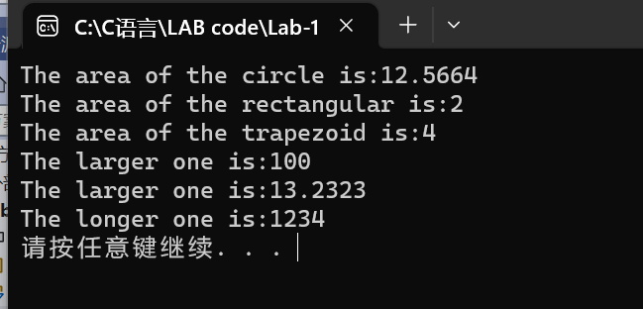
Discussion:
1．Most difficult parts
（What were the most difficult parts of your program to implement?）
Nope
2．Bugs and/or Errors
(List all the program bugs/errors you encountered and how you corrected them.)
Nope

